NAME: DERRICK KIRIMI
REG NO: ENM221-0040/2018
COURSE: B. SC. MECHATRONIC ENGINEERING
UNIT: PRODUCTION TECHNOLOGY
TERM PAPER

PRODUCTION PROCESS OF KENPOLY CONTAINERS, COCACOLA BOTTLES(GLASS), KALUWORKS TEAPOT, EA PORTLAND CEMENT AND KENYA CLAY PRODUCTS ROOFING TILES

Introduction
The aim of production technology is the transfer of scientific knowledge into economically usable and technologically controllable production systems. The choice of production process depends on the material being used, the economic feasibility of the method and the level of technological capability. The chosed method should also meet safety and regulatory standards criteria such as regarding health and consumer welfare. There should be minimization of waste and maximum cooperation with adjoining and related plants.

In this term paper, the choice of production process and base material on production of select component will be outlined.

1. KENPOLY CONTAINER
Base material: polypropylene. Ideal food-safe product for high-heat manufacturing processes.
Process:
Extrusion blow molding is used to make high-performance and high reliability plastic containers with low weight and cost.
First, round hollow tube (parison) is formed by an extruder.
A mold cavity composed of two halves closes around the parison and punches off one end. Then, compressed air shapes the container, it cools, and excess plastic is trimmed.
Injection blow molding is performed in three important stages. First, melted plastic is injected into a mold to produce a parison. Compressed air then blows through a core pin to expand the mold. Finally, the container is transferred to a third station for ejection.
Injection molding
- The plastic raw material in granule form is melted ina a chamber and inseted into the injection moulding machine where it is passed into a mould with the tapered, wide-mouthed shape of the KlipLock food container.
- To make the base material conform to the mould shape pressure is used to form it to the required thickness.
- Cooling and hardening.
- Ejection from mould
- Quality control – uniform wall thickness to prevent weakness. Material deposition and air bubble detection.

2. COCACOLA GLASS BOTTLE
Base material:
Commercial grade sodium carbonate
Calcium Carbonate
Sand
Cullet
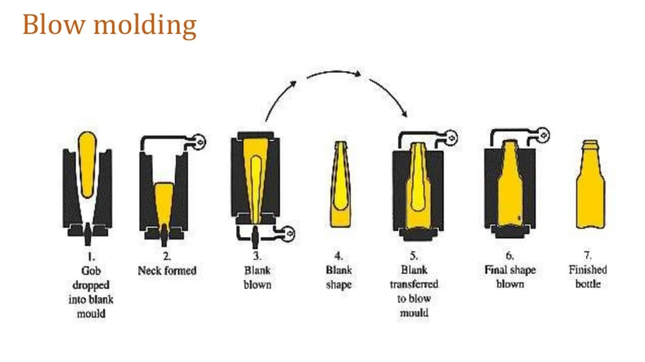
Process:
- Sand is predried and ground to 2mm particles.
Cullet is added at a 10% concentration ratio
Glass to be recycled is added to reduce melting temperature.
- The batch is weighed and measured
- This is added down the feed hopper
- The batch is fed into the large complex glass furnace at a controlled rate.
- Molten glass at 2350 degrees celcius from the throat is cooled at the forehearth to about 2200
- The glass is conditioned to a syrup consistency
- Distribution of the batch into precisely measured sizes of molten glass called gobs.
These are fed by gravity into the forming machine.
- Container Forming:
- The gob is guided into a blank mould.
- Air is injected int the mould and the neck formed.
- Injecting more air into the mould through the neck, the mould is inverted at 180 degrees and the parison transferred from the blank mould to the blow mould.
- Parison reheating is done.
- Blowing the container into shape is done aby injecting air.
- Removal from mould and annealing.
- Annealing:
- The bottle is reheated to about 1050 degrees celcius, and gradually cooled to 390 degrees.
Cooling at an even rate eliminates stresses that result in cracking and shattering.
- Exterior coating to reduce abrasions is done with cold end water.

Inspection and packaging:
Sidewall and base scans are done, as well as sealing surface flatness verification and critical “fit and function” dimensions verification for tops.
Automatic packaging equipment layers

3. Kaluworks Teapot
Base material : aluminium
Aluminium is nontoxic and not prone to rust.

Production Process
- Large aluminium plates are blanked for reduction into smaller parts.
- Deep drawing: the aluminium plate is radiallly drawn into a forming die by the mechanical action of a punch to form the cylindrical part of the teapot.
- Neck-spinning: to obtain a hollow axisymmetrical shell, a pressing tool holds the metal part over a rotary chuck on a CNC machine.
- Punching: The part is placed in a power press and moved along x and y axis according to data entered positioning the parts under the puching ram for puching of articulation holes for the pourer and handle.
- Handle shape-forming: handles are formed by bending thin strips drawn from the metal sheet.
- Handle riveting and adapter riveting
A riveting machine rivets the handle to the teapot body.
- Trimming and joggling
In this process, the edge of sheet metals is cut without any burrs.

4. East African Portland cement
Base material : limestone
Process of production:
- Drying is done at 1450 degrees celcius in the kiln, during which the chemical processses below occur:
Evaporating all moisture in th elimestone.
Calcining the limestone to produce free calcium oxide.
Reacting the calcium oxide with the minor materials(bauxite, iron core and kunkur)
From drying results clinker, a black nodular product with desired hydraulic properties.
- Material from the 4 cyclone preheater tower is discharged to a rotary kiln diameter 3.7mm and length 54mm.
- The rotary kiln is fired with an intense flame formed by burning furnace oil or coal.
- The rotary kiln discharges red-hot clinker at a temperature of 100 degrees, cool eno;ugh to be handled on conveying equipment.
Stage of Cement Manufacture
There are six main stages of cement manufacturing process.

Stage 1
Raw Material Extraction/Quarry
The raw cement ingredients needed for cement production are limestone (calcium), sand and clay (silicon, aluminum, iron), shale, fly ash, mill scale and bauxite. The ore rocks are quarried and crushed to smaller pieces of about 6 inches. Secondary crushers or hammer mills then reduce them to even smaller size of 3 inches. After that, the ingredients are prepared for pyroprocessing.

Stage 2
Grinding, Proportioning and Blending
The crushed raw ingredients are made ready for the cement making process in the kiln by combining them with additives and grinding them to ensure a fine homogenous mixture. The composition of cement is proportioned here depending on the desired properties of the cement. Generally, limestone is 80% and remaining 20% is the clay. In the cement plant, the raw mix is dried (moisture content reduced to less than 1%); heavy wheel type rollers and rotating tables blend the raw mix and then the roller crushes it to a fine powder to be stored in silos and fed to the kiln.

Stage 3
Pre-Heating Raw Material
A pre-heating chamber consists of a series of cyclones that utilizes the hot gases produced from the kiln in order to reduce energy consumption and make the cement making process more environment-friendly. The raw materials are passed through here and turned into oxides to be burned in the kiln.

Stage 4
Kiln Phase
The kiln phase is the principal stage of the cement production process. Here, clinker is produced from the raw mix through a series of chemical reactions between calcium and silicon dioxide compounds. Though the process is complex, the events of the clinker production can be written in the following sequence:

Evaporation of free water
Evolution of combined water in the argillaceous components
Calcination of the calcium carbonate (CaCO3) to calcium oxide (CaO)
Reaction of CaO with silica to form dicalcium silicate
Reaction of CaO with the aluminum and iron-bearing constituents to form the liquid phase
Formation of the clinker nodules
Evaporation of volatile constituents (e. g., sodium, potassium, chlorides, and sulfates)
Reaction of excess CaO with dicalcium silicate to form tricalcium silicate
The above events can be condensed into four major stages based on the change of temperature inside the kiln:

100°C (212°F): Evaporation of free water
100°C (212°F)-430°C (800°F): Dehydration and formation of oxides of silicon, aluminum, and iron
900°C (1650°F)-982°C (1800°F): CO2 is evolved and CaO is produced through calcination
1510°C (2750°F): Cement clinker is formed
The kiln is angled by 3 degrees to the horizontal to allow the material to pass through it, over a period of 20 to 30 minutes. By the time the raw-mix reaches the lower part of the kiln, clinker forms and comes out of the kiln in marble-sized nodules.

Stage 5
Cooling and final grinding
After exiting the kiln, the clinker is rapidly cooled down from 2000°C to 100°C-200°C by passing air over it. At this stage, different additives are combined with the clinker to be ground in order to produce the final product, cement. Gypsum, added to and ground with clinker, regulates the setting time and gives the most important property of cement, compressive strength. It also prevents agglomeration and coating of the powder at the surface of balls and mill wall. Some organic substances, such as Triethanolamine (used at 0.1 wt.%), are added as grinding aids to avoid powder agglomeration. Other additives sometimes used are ethylene glycol, oleic acid and dodecyl-benzene sulphonate.

The heat produced by the clinker is circulated back to the kiln to save energy. The last stage of making cement is the final grinding process. In the cement plant, there are rotating drums fitted with steel balls. Clinker, after being cooled, is transferred to these rotating drums and ground into such a fine powder that each pound of it contains 150 billion grains. This powder is the final product, cement.

Stage 6
Packing and Shipping
Cement is conveyed from grinding mills to silos (large storage tanks) where it is packed in 20-40 kg bags. Most of the product is shipped in bulk quantities by trucks, trains or ships, and only a small amount is packed for customers who need small quantities.

5. Kenya clayworks roofing tiles
Base materilal: clay
Production process:
- Clay is obtained by quarrying close to the company.
- Raw materials preparation and shaping:
To obtain a homogenous solution the clay is laid out and dried.
Stockpiling, crashing to a smaller grain size then re-stockpiling.
After obtaining the required moisture content, clay is extruded to obtain the tiles shape required and pressed in moulds.
- Drying and firing
- High temperature firing in kilns imparts durability and exceptional qualities.
- Packaging and storage;
following cooling , the finished product is made ready for dispatch.

